
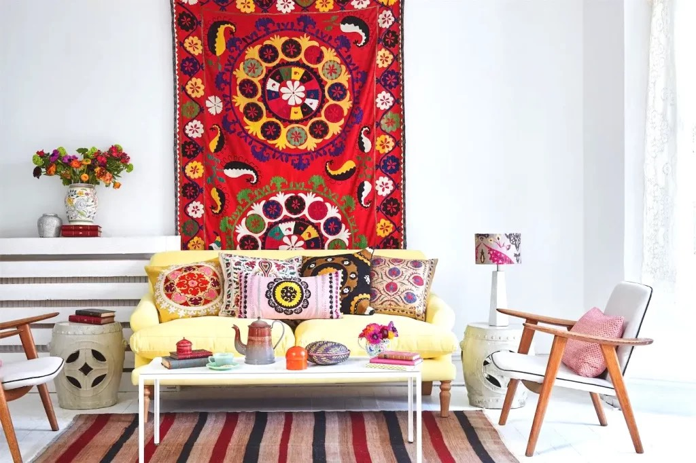
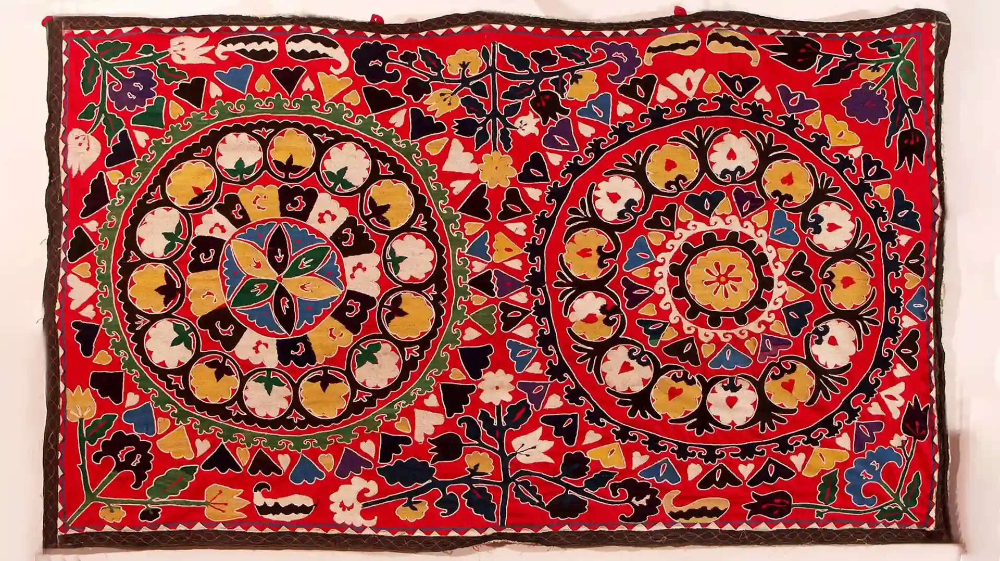
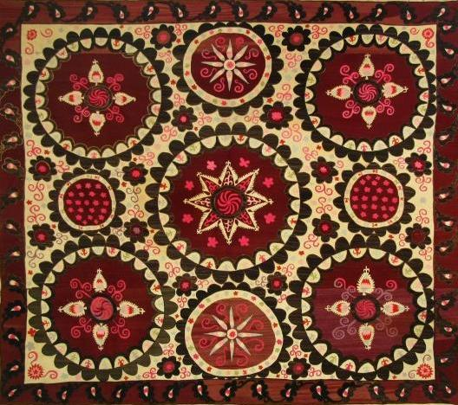
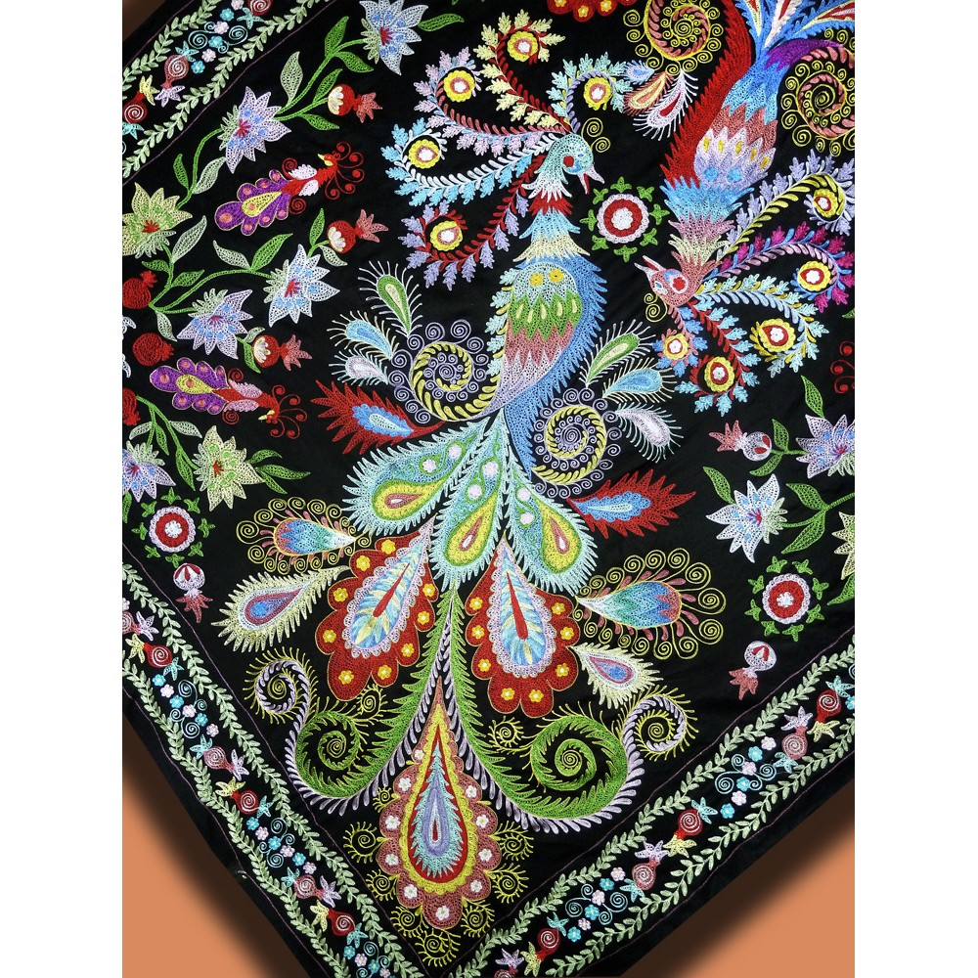
Conservation In Uzbekistan, different types of creativity, handcrafts that are made by talented people, but mainly with heart, they are considered to be valuable for centuries. However, the most valuable and disappearing treasure is Suzané. This report will discuss information about suzané and the importance of preserving it today. Suzané is a traditional embroidered fabric, and in the past, it was used as a decorative bedspread, a wall carpet, or a wedding dowry. The word «suzan» is derived from Persian and means as «needle». This bedspread attracted people’s attention with its large size, colorful embroidery, even with its superior quality. In addition to Uzbekistan, suzané is also developed in countries such as Tajikistan and Iran. Embroidery was done using such techniques as tassel embroidery, stem embroidery and other types of equipments. Furthermore, suzané was embroidered with silk or cotton threads, as well as, natural dyes were used to add color. For example, in the past, if a girl was expecting a wedding, she would order a suzané from a weaver based on her own design, and each piece of handcraft was unique in its own way. Red and blue embroidery was especially popular among others, and it filled every home with its beauty. Each pattern and symbol in suzané had a special meaning. 1. Floral motives. Flowers is the most common element in suzané, flowers such as roses, poppies and lotuses. They reflect natural beauty, love and harmony. 2. Birds. Birds in suzané symbolize family happiness. If there are embroidered birds, it is a symbol of family and marriage. 3. The Sun and the stars. The Sun and the stars are two elements that are considered as powerful protectors. The Sun symbolizes the juiciest element of the suzané. It signifies family wealth and abundance, as well as numerous offspring. Moreover, there is interesting fact that suzané is preserved in other countries. For instance, in Metropolitan Museum that is located in New York. There are stored different kinds of embroideries including suzané. These canvas arrived to the museum in various ways. How it happened? In XX century, collector namely Caroline Kane bequeathed canvases to the museum, thanks to her, they are kept in such famous museum, and this shows how important and valuable the work of Central Asia. Comparing to the past, suzané is losing its significance, the reason for it is that technology is developing more and more every year, replacing handicrafts. People might forget such beauty as suzané, which embodies the purity and perseverance of work. For instance, robotics, which replaces human labor, is now actively developing in every city of Uzbekistan. Every year factories produce a million of canvases, carpets and other products. Nevertheless, nothing compares to suzanné’s hand-sewn work, therefore, I think it is important for Uzbek culture to preserve such a beautiful cultural heritage. In conclusion, suzané is an important and necessary treasure for today’s Uzbekistan. In view of the fact that it shows how rich suzané with its interesting stories from the past, what high-quality materials were used to sew it, and it brought happiness to every corner of the house. Also, it was considered as the best Uzbek girl’s dowry.
Suzané
Floral suzané
The Sun and the stars embroidery
Birds embroidery

